Major Concepts fromCh 1-6
Please answer each question carefully using the lecture slides, textbook, and notes.
- What studies are found at the bottom of the Quality of Evidence Pyramid? What studies are found at the top? If a close friend recommends a new food or diet based on an article they read, where does this fall on the pyramid? Please Explain
The studies that are found at the bottom of the quality of evidence pyramid include background information and expert opinion while those found at the top include systematic reviews. The recommendations from a close friend on a new food or diet based on an article they read would fall under the critically-appraised individual articles in the pyramid.
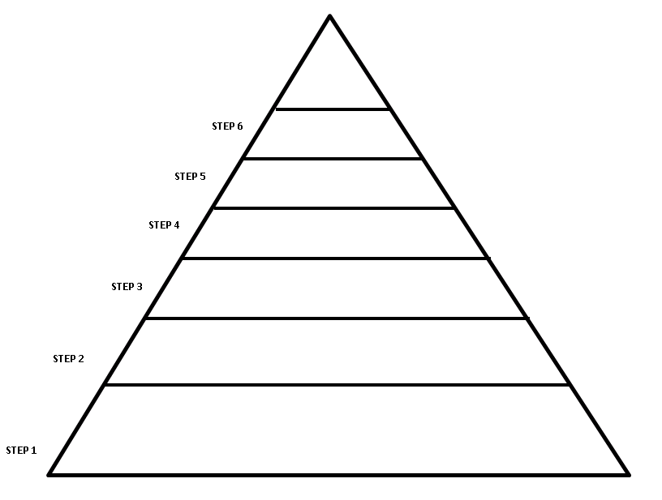

2. Smart goals are more successful at changing behavior than general goals because they are realistic in that they are set to be achievable; general goals could be difficult to achieve. In addition, smart goals are measurable and actionable. For instance, having weight management as a goal, one can decide to walk briskly for 30 minutes, 5 times a week. General goals would put it as exercise per day without specifying what kind or for what duration.
3. The primary function of the digestive system is digestion and absorption of food. Digestion involves both mechanical and chemical aspects. In mechanical digestion, food is broken down into smaller pieces through chewing and churning while chemical digestion involves use of enzymes to breakdown food. Absorption involves movement of molecules (by passive diffusion or active transport) from the digestive tract to adjacent blood and lymphatic vessels.
4. The primary site of digestion is the small intestines; it is upto 6 meters long and 2-3 centimeters wide.
5. Please explain how the following contributes to digestion
- Esophageal Sphincter – The upper esophageal sphincter (UES) keep food and secretions from going down the windpipe while the lower esophageal sphincter (LES) prevents acid and stomach contents from traveling backwards from the stomach.
- Microvilli of the Small Intestine – increase the surface area of the small intestine allowing more area for nutrients to be absorbed.
- Enzymes – they assist in chemical breakdown of food from complex materials to simple soluble substances.
- Stomach acid – The acid activate digestive enzymes, and make ingested proteins unravel so that digestive enzymes break down the long chains of amino acids.
- Sodium bicarbonate – helps neutralize stomach acid generated during the digestive process and breaks down certain enzymes.
- Thick mucus layer of the stomach – lubricates food masses in order to facilitate movement within the stomach and the forms of a protective layer over the lining epithelium of the stomach cavity.
- Common Bile Duct of the small intestine– carries bile from the gallbladder and empty it into the upper part of the small intestine (the duodenum).
- Bile Salts – solubilize dietary fats in the watery environment of the small intestine to form tiny droplets that can be absorbed.
6. Please describe why this is the major site of digestion and absorption.
What organs are feeding into the small intestine? Please label each
How does each organ contribute to the breakdown of food?

- Liver

- Gall bladder

- duodenum
- Pancreas
The gall bladder and the pancreas are the organs that feed into the small intestine.
Gall bladder produces bile salts that emulsify fats into tiny droplets while the pancreas produces pancreatic enzymes that contain trypsinogen, chymotrypsinogen, pancreatic amylase, and pancreatic lipase.
7. Humans are made up of atoms, molecules, cells, tissues, organs, and organ systems. Please explain how nutrition plays a role at each of these levels of organization:
8. Please list two diseases that have chronic low-grade inflammation
Obesity
Depression
9. Blood glucose must be tightly regulated by hormones to protect the body from tissue damage, coma, and death. Please explain how insulin and glucagon regulate blood sugar.
Insulin helps the cells absorb glucose, reducing blood sugar and providing the cells with glucose for energy. When blood sugar levels are too low, the pancreas releases glucagon. Glucagon instructs the liver to release stored glucose, which causes blood sugar to rise.
10. Why are the bran and germ of a whole grain important for a healthy diet? What is wrong with only eating the endosperm in refined grains like white bread?
Whole grains products such as whole wheat bread contain more fiber than refined grains (such as white bread). Fiber helps to control blood glucose by delaying the rise in blood glucose after the food is eaten. Fiber has also been associated with an improvement in insulin resistance. Therefore, even though the total carbs in whole grain products and refined grained products is about the same, there is still benefit from eating foods prepared with whole grains. The difference between whole grains and refined grains is that whole grains include all three parts of the grain (bran, germ, and endosperm), while refined grains do not include the bran or germ (these are removed during processing, leaving only the endosperm).
11.
Healthy Fats:  Unsaturated fats | Unhealthy Fats:  Saturated fats  Trans fat
Contribution to inflammation:  Protects against inflammation | Contribution to inflammation:  Triggers inflammation
Food Sources:  Avocados, olive oil, nuts, seeds, and fatty fish among other seafood | Food Sources:  Saturated fats:  - fatty cuts of beef, pork, and lamb  - dark chicken meat and poultry skin  - high-fat dairy foods (whole milk, butter, cheese, sour cream, ice cream)  - tropical oils (coconut oil, palm oil, cocoa butter)  - lard  Trans fat:  cakes, cookies, crackers, animal products, margarine, fried potatoes, potato chips, popcorn

12. HDL and LDL cholesterol impact Cardiovascular Disease.Please explain which is considered “good”, which is considered “bad”, and how they impact disease.
HDL cholesterol is good while LDL cholesterol is bad for the body. High levels of LDL cholesterol lead to atherosclerosis increasing the risk of heart attack and ischemic stroke. HDL cholesterol reduces the risk of cardiovascular disease as it carries cholesterol away from the blood stream.
13. Why are Omega-3 fats important? Please list three ways to add more to the diet:
They help in preventing and managing heart disease by lowering blood pressure, reducing triglycerides, and slowing the development of plaques in arteries.
To add more omega 3 to the diet, eat fruit at breakfast and as a daily snack, use plenty of antioxidant-rich natural seasonings, and add plant-based fats to every meal.
14. Your friend is trying to avoid trans fats. She reads the Nutrition Facts panel of a box of crackers that states “0g trans-fat”. Should she eat the crackers? Please explain.
She cannot trust the label in deciding whether the food has zero trans fats but she should check the ingredients of the cracker before deciding to eat them or not.
15.
Macronutrients | Monomers | Storage Form | Where is it stored
Carbohydrates | Monosaccharide (glucose, fructose, galactose) | glycogen | Liver and muscles
Lipids | Glycerol and fatty acids | Cell membranes, adipose tissue, lipoproteins, fat cells | Adipose tissue (in cells known as adipocytes
Proteins | Amino acids | Structural proteins | Liver, muscles

16. List the functions of Carbohydrates:
- Providing energy and regulation of blood glucose
- Sparing the use of proteins for energy
- Breakdown of fatty acids and preventing ketosis
- Biological recognition processes
- Flavor and Sweeteners
- Dietary fiber
17. List the functions of Lipids:
- Energy Production and Storage
- Insulation and Protection
- Digestion and Absorption
- Cell Wall Structure
- Hormone Production
18. List the functions of Proteins:
- Growth and Maintenance
- Biochemical Reactions (enzymes
- Acts as a Messenger (hormones)
- Provides Energy
- Provides structure (keratin, collagen, elastin)
- Bolsters Immune Health
- Transports and Stores Nutrients
19. Please draw or describe the process of denaturing a protein. Please explain why it is useful to denature proteins during digestions, but why we would not want to denature our own proteins like enzymes, immune cells, and muscle tissue.
Denaturation of proteins involves the disruption and possible destruction of both the secondary and tertiary structures. Since denaturation reactions are not strong enough to break the peptide bonds, the primary structure (sequence of amino acids) remains the same after a denaturation process. Denaturation disrupts the normal alpha-helix and beta sheets in a protein and uncoils it into a random shape. Denaturation occurs because the bonding interactions responsible for the secondary structure (hydrogen bonds to amides) and tertiary structure are disrupted. In tertiary structure there are four types of bonding interactions between "side chains" including: hydrogen bonding, salt bridges, disulfide bonds, and non-polar hydrophobic interactions. which may be disrupted. Therefore, a variety of reagents and conditions can cause denaturation. The most common observation in the denaturation process is the precipitation or coagulation of the protein.
20. List, draw, or describe the pathway of fat digestion from the small intestine to the lymph. Include the digestive secretions that help break down the fat and what happens in the cell of the small intestine to allow it to travel in the circulation.
On reaching the duodenum, fats are mixed with the bile and pancreatic juice which contains lipase. The bile salts emulsify the fat before the action of lipase. The emulsification is also brought about by monoglycerides, phospholipid, and lysolecithin. The secreted inactive pancreatic lipase is activated by bile and Calcium salts. The surface area of the emulsified fat becomes increased for which the rate of reaction of lipase is increased. Pancreatic lipase hydrolyzes 1- and 3-positions of the triglycerides leaving a mixture of 2- monoglycerides, 1, 2- and 2, 3-diglycerides as well as the soaps of the free fatty acids. The pancreatic juice also contains phospholipase and cholesterol-esterase which hydrolyze phospholipid and esterified cholesterol. All long chain fatty acids present in the intestinal wall are reincorporated into triacylglycerol, which are transported to the lymphatic vessels of the abdominal region (the so-called lacteals) for distri­bution to the rest of the body.
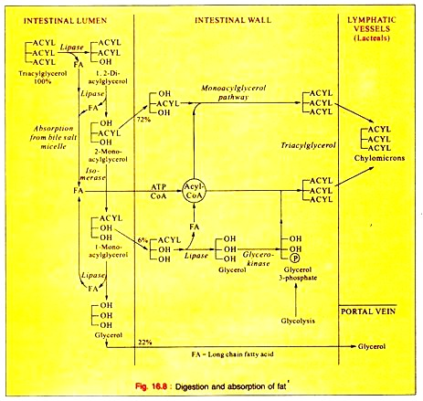

Family Tree Assignment
Now that you have learned the link between nutrition and chronic disease, find out what your genetic risk factors are. To the best of your ability, trace your lineage back to your great grandparents. Find out what chronic diseases each family member might have. Use this information to create a family tree. This may be provided in a simple list format, hand drawn, or typed. If you do not have access to your full family lineage, do the best you can. The goal is to know what your risks are and what lifestyle changes you can make to promote disease prevention.
- Demonstrate an understanding of nutritional principles in both health & illness
The nutrition principles that affect health and illness involve an understanding of the role of each of the five food content i.e. carbohydrates, proteins, lipids, minerals, vitamins, and water. It is imperative to understand the recommended amounts of each of the components as well as their sources. This would help manage many of the lifestyle diseases and maintain body fitness.
- Describe the relationships between nutrition and human physiology.
Physiology is the proper functioning of the body; nutrition is the fuel for the performance of the function. Food is essential for growth and development. Physiology becomes an interlink between nutrition and healthy human body. This includes processes like digestion, absorption, and intermediary metabolism of nutrients. The analysis of nutrients and its impact on daily life appropriates for the physiological disturbances caused. Any nutrient, which is in excess or deficient, can cause alterations in the general metabolism and the health of a person.
- Apply knowledge of nutrition to real-life ex
Nutrition is key to my weight management; I watch the foods that I eat and do daily exercise through evening walks and riding. I have adopted a nutrition pattern that limit foods with empty calories such as fries and alcohol and focus more on whole grain foods such as oats, legume, and other nutritious foods such as vegetables and seafood.
- Acquire knowledge about the role of Nutrition in disease prevention
The right diet can help fight conditions and illnesses like heart disease, diabetes, osteoporosis, cancer and obesity among many others. Making sure children have the correct amount of nutrients and foods from major food groups is key to preventing obesity among other lifestyle diseases.
Family Tree for chronic diseases
Family Member | Health summary
Great paternal grandfather 1 | Death unknown
Great paternal grandmother 1 | Death unknown
Great paternal grandfather 2 | Died of an accident
Great paternal grandmother 2 | Death unknown
Great maternal grandfather 1 | heart attack, obese
Great maternal grandmother 1 | Hypertension, rheumatoid arthritis
Great maternal grandfather 2 | Died in road accident
Great maternal grandmother 2 | Diabetes mellitus
Paternal grandfather | Benign prostate hyperplasia, Hypertension, Diabetes Mellitus
Paternal grandmother | Hypertension, rheumatoid arthritis
Father | Diabetes mellitus, Hypertension
Maternal grandfather | Unknown, died of heart attack
Maternal grandmother | Health unknown, died in sleep
Mother | Slightly diabetic no medications needed, just diet
Me | Healthy

